**Calculation and Discussion**

Alex de Vries, a bitcoin specialist at PwC, estimates that the current global power consumption for the servers that run bitcoin's software is a minimum of 2.55 gigawatts (GW), which amounts to energy consumption of 22 terawatt-hours (TWh) per year—almost the same as Ireland.

Currently, the tool estimates that Bitcoin is using around seven gigawatts of electricity, equal to 0.21% of the world's supply. That is as much power as would be generated by seven Dungeness nuclear power plants at once.

Bitcoin mining profit depend on four parts-Hash rate, Bitcoin price, Power consumption (watts), Cost per kw/h$.Hash rate, Bitcoin Price increase and Power consumption, cost per kw/h decrease then get profit.

**What is hash Rate?**

The hash rate, is a measure of how many times the network can attempt to complete this puzzle every second. This means that hash rate is a good indicator of the Bitcoin network's health ASIC models.

**How much electricity does it take to mine one Bitcoin?**

If we run an ASIC (Bitmain Antminer S17) 24/7 for a year it will produce about 0.2646 BTC, at a cost of about 12960 KWh (1500Watt = 1.5 KWh) power in a year. Depending on power prices it will cost anywhere from $816.48 ($0.063 per watt) to mine 0.2646 BTC.

**How much can you mine Bitcoin in a day?**

There are 144 blocks per day are mined on average, and there are 12.5 bitcoins per block.

So everyday about $144*12.5=1800$ BTC being mined.

**How much does it cost to mine 1 Bitcoin?**

The cost of mining a bitcoin is subjectable if we use hash rate of 377.93 TH/s which is about 4 ASIC (Bitmain Antminer S17) chip it will cost us about $3265.92 to mine 1 BTC [Electric price is taken as Bangladesh electric price charge which is $0.063 per watt].

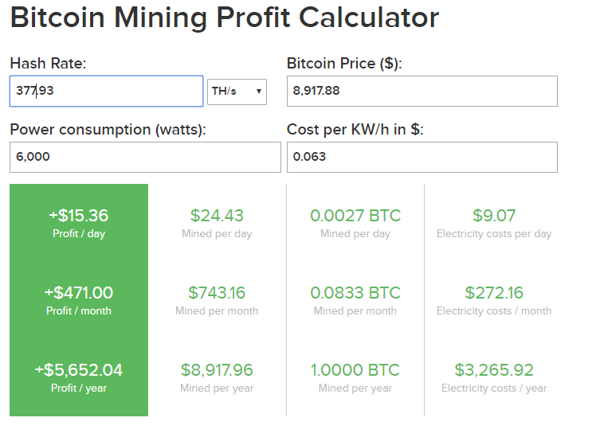

Fig1: Cost Calculation of ASIC (Bitmain Antminer S17) chip to mine 1 BTC.

**What is the Fastest Bitcoin miner?**

ASIC (Bitmain Antminer S17+ 100TH/s @ 1500W + PSU by PROMINER) has the highest hash rate of 100TH per second with the energy consumption of 1500w.

**How much Bitcoin are left to mine?**

From today’s point of view are 2,741,388 bitcoins left to be mined.

**How Many Bitcoins Are There Now in Circulation?**

There are currently 18,258,613 bitcoins in existence. This number changes about every 10 minutes when new blocks are mined. Right now, each new block adds 12.5 bitcoins into circulation.

**How Many Bitcoins Have Been Mined Already?**

Since bitcoins can only be created by being mined, all the bitcoins in existence are all bitcoins that have been mined. The total is 18,258,613 BTC.

**How Many Bitcoin Blocks Are There Today?**

There have been 609,003 blocks mined.

**How Many Bitcoin Have Been Stolen?**

It's unclear exactly how many bitcoins have been stolen.850,000 BTC were stolen in the Mt. Gox hack, which was the largest Bitcoin hack ever. Another 120,000 BTC were stolen from Bitfinex in 2016. Together, that adds up to about 970,000 BTC. Stolen BTC, however, does mean lost BTC. It's likely these stolen coins are still circulating, and may not even be in the hands of the original thieves.

**What Happens When All 21 Million Bitcoins Are Mined?**

Right now, miners earn most of their income via the block reward. When all 21 million bitcoins are mined, there won't be a block reward to pay to miners. When a Bitcoin user sends a BTC transaction, a small fee is attached. These fees go to miners and this is what will be used to pay miners instead of the block reward.

**How much power will be needed if** **we merge 1000 pc?**

Let’s assume each has PC has core i7 3.40 GHz clock speed, 500Watt power supply and cost of electricity 0.063$(in BD)

***Clock Speed Calculation***

1 PC of Core i7 Processor has 3.40 GHz Clock Speed

1000 PC of Core i7 Processor has = $3.40 GHz * 1000 (PC)$

= $3400$ GHz

= $3.4$ THz [1000 GHz = 1 THz]

So, we can see 3.4 THz Clock Speed needed for 1000 PC

***Power Consumption Calculation***

1 PC of Core i7 3.40 GHz Processor Consumed 500 Watt Power

1000 PC of Core i7 3.40 GHz Processor Consumed = $500 Watt * 1000(PC)$

$=500000 Watt$

$=0.5 MWh$

$=500KWh$ [1000 KWh = 1 MWh]

***Hash rate Calculation***

1 PC of Core i7 3.40 GHz Processor has Hash Rate 291 h/s

1000 PC of Core i7 3.40 GHz Processor has Hash Rate $= 291 h/s * 1000(PC)$

$=291000 h/s$

$=0.0002916 GH/s$

$$[1 GHz=10^9 h/s]$$

So, we can see that if 1000 core i7 3.4GHz PC used, it will needed 5,00000 Watt or 500 KWh or 0.5 MWh power with the price of $0.063 per watt ,which will produce -$756.00 in a day which is a negative rate that means it will not give us profit but it will make us lose our money.

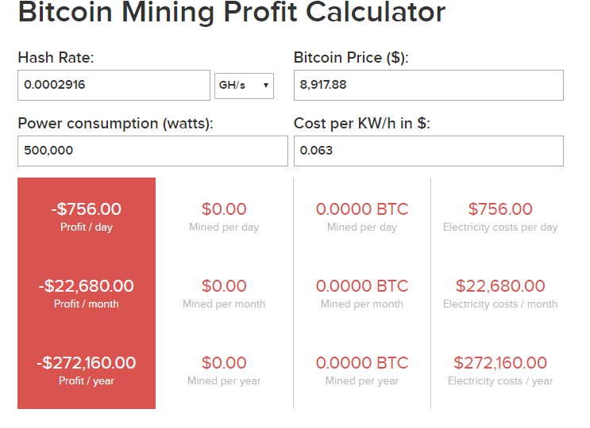

Fig 2: Profit Calculation of 1000 Core i7 2.4 GHz PC

Now see, if we use an ASIC (Bitmain Antminer S17) chip it has 100TH/s or 100000 GH/s and it consumes only 1500 Watt power with the price of $0.063 per watt, which will produce $4.20 profit per day and $128.60 profit per month. Which is profitable

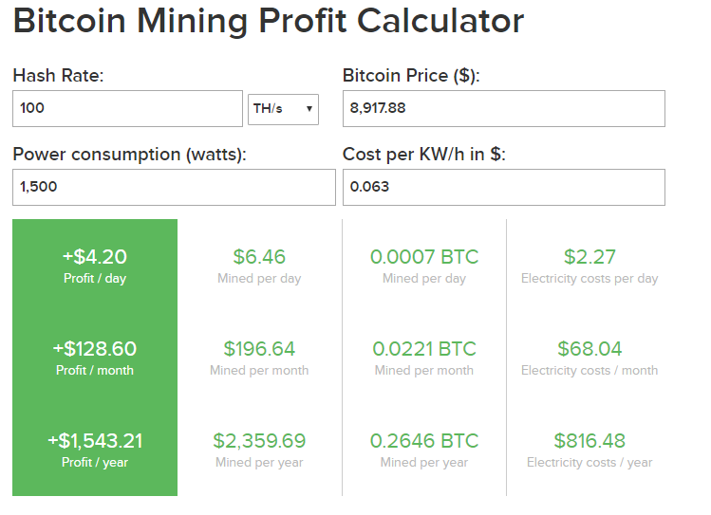

Fig 3: Profit Calculation of ASIC (Bitmain Antminer S17) chip.

|  |  |  |
| --- | --- | --- |
| **Criteria** | **1000 PC of Core i7 3.4 GHz** | **ASIC(Bitmain Antminer S17)**  **chip** |
| Hash Rate(GH/s) | $$0.0002916 GH/s$$ | 100 TH/s |
| Power Consumption | $$500000 Watt$$ | 1500 Watt |
| Heat generated | Very High | Comparatively low |
| Profit/Loss (Per day) | -$756.00 (Loss) | +$4.20 (Profit) |

Table 1: Difference between 1000 PC of Core i7 3.4 GHz and

An ASIC (Bitmain Antminer S17) chip.

If we use 1000 PC for bitcoin mining it is possible to mine coins but there will be no profit in fact can be in loss.

**Reference:**

How much Bitcoin Left: https://www.bitcoinblockhalf.com/

ASCI model: https://promineruk.com/product/bitmain-antminer-s17-100th-s-1500w-psu-by-prominer/

Mining Calculation: https://www.buybitcoinworldwide.com/mining/calculator/

Hash Rate converter: https://coinguides.org/hashpower-converter-calculator/